ENHANCEMENT THERMAL EFFICIENCY OF PTSC BY USING NANOFLUID

A.Y. Al-Rabeeah¹, I. Seres², and I. Farkas³

¹Doctoral School of Mechanical Engineering, ²Institute of Mathematics and Basic Science,
³Institute of Technology
Hungarian University of Agriculture and Life Sciences
Páter K. u. 1., Gödöllő, H-2100 Hungary
E-mail: Al-Rabeeah.Asaad.Yasseen.Ali@phd.uni-mate.hu

The parabolic trough solar collector (PTSC) is widely used concentrating solar technology. The traditional PTSC is used in a variety of low- and high-temperature applications.
The aim of this research is to increase the thermal efficiency of PTSC by using the nanofluid as a working fluid. Because of its superior thermophysical properties compared to conventional working fluids like water, ethylene glycol, and oil, nanofluid has gained attention as a new and efficient heat transfer fluid (Al-Rabeeah et al., 2022).
As shown in the figure below, some PV/T modules are designed and structured with and without a glass cover. This study examined the impacts of the glass covering on the thermal and electrical performance of the hybrid solar collector.
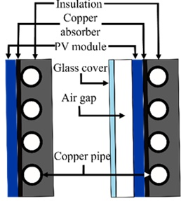

The two-step method involves the producing nanopowder. Firstly, it is obtained through inert gas condensation, chemical vapor deposition or mechanical alloying. Then it is mixed with the base fluid using ultrasonic agitation. The table below shows the calculation results.
 | on-off | flow rate control
η, % | 42,43 | 48,03
ST, - | 19,87 | 32,65
noTr, % | 70,57 | 96,72
Mixing of nanoparticles to the working fluid is an effective method to increase the thermal energy collected and the thermo-physical properties of nanofluid.
Acknowledgements
This work was supported by the Stipendium Hungaricum Programme and by the Mechanical Engineering Doctoral School, Hungarian University of Agriculture and Life Sciences, Gödöllő, Hungary.
References
Al-Rabeeah, A.Y., Seres, I., Farkas, I.: Recent improvements of the optical and thermal performance of the parabolic trough solar collector systems, Facta Universitas, Series: Mechanical Engineering, Vol. 20, No 1, 2022, pp. 73–94.
https://doi.org/10.22190/FUME201106030A

